Student Name ____JEREMY PERRY_______________________________
I am using __X__ MySQL ____ SQL Server 2008

This is the second part of your final examination for CIS 251 - Introduction to SQL.

Run additional SQL Statements against your database. Create the following SQL statements; run them against your newly created tables. You will be copying both your SQL statements and your results into THIS document. Be sure you have the complete results screen showing; including the status of each SQL statement. These screen shots should be complete, do not cut off your results.

Keep all questions in tack in this document. Do not delete the questions.

- Show all of the information available about the contributors.

SELECT *
FROM CONTRIBUTOR

- Show all of the information available about the campaigns.

SELECT *
FROM CAMPAIGN

- Show all of the information available about the pledges.

SELECT *
FROM PLEDGE

- For all of the contributors, find their last plus their first name as Contributors (as a single field), and determine the total amount of money they have contributed to all campaigns as Total_Pledges.

SELECT CONTRIBUTOR_ID, SUM(AMOUNT)
FROM PLEDGE
GROUP BY CONTRIBUTOR_ID

- We would like to create a mailing to all individuals that live in the same city as Mr. Nagy.

SELECT CONT_NAME, CONT_ADDRESS, CONT_CITY, CONT_STATE, CONT_ZIP
FROM CONTRIBUTOR
WHERE CONT_CITY = (SELECT CONT_CITY
FROM CONTRIBUTOR
WHERE CONT_NAME = 'Helvetius Nagy')

CONT_NAME | CONT_ADDRESS | CONT_CITY | CONT_STATE | CONT_ZIP
Helvetius Nagy | 1200 Main St. | Kirkland | WA | 98034

- We often need to see the totals amounts that have been contributed to each campaign. Create a view and call this view Campaign_Total, which shows the campaign identification, the campaign name and the total amount of pledges received for the campaign as Total_Pledge. Select all the information available from the view. (2 SQL statements)

//QUESTION 6A
CREATE VIEW CAMPAIGN_TOTAL
(CAMPAIGN_NAME, TOTAL) AS
SELECT C.CAMPAIGN_NAME, SUM(P.AMOUNT)
FROM CAMPAIGN AS C LEFT OUTER JOIN PLEDGE AS P
ON C.CAMPAIGN_NAME = P.CAMPAIGN_ID
GROUP BY CAMPAIGN_NAME

//QUESTION 6B
SELECT *
FROM CAMPAIGN_TOTAL

- Using the view you created in question #6, find the campaign name, the amount of money the campaigns are short of their goal.

SELECT CT.CAMPAIGN_NAME, (SUM(CA.FUNDRAISING_GOAL - COALESCE(CT.TOTAL, 0))) AS GOAL_REMAINING
FROM CAMPAIGN_TOTAL AS CT, CAMPAIGN AS CA
WHERE CT.CAMPAIGN_NAME = CA.CAMPAIGN_NAME
GROUP BY CT.CAMPAIGN_NAME

- A new pledge has been received, insert the following information AND run a select statement, which shows all the information about the new record (only) in the PLEDGE table. (2 SQL statements)
Contributor: Karl Jablonski
Amount: $100
Pledge made on July 31, 2000
For the campaign of Books for Schools
Karl states the check is in the mail.

//QUESTION 8a
INSERT INTO PLEDGE
VALUES('Karl Jablonski', 'Books for Schools', '2010-07-31', 100, 'N', null)

//QUESTION 8B
SELECT *
FROM PLEDGE

- The pledge created in #8, was paid on 8/1/2000, please update the record, AND run a select statement which shows all the information about the updated record (only). (2 SQL statements)

//QUESTION 9A
UPDATE PLEDGE
SET DATE_PAID = '2010-08-01'
SET PAID = 'Y'
WHERE CONTRIBUTOR_ID = 'Karl Jablonski'
AND CAMPAIGN_ID = 'Books for Schools'

//QUESTION 9B
SELECT *
FROM PLEDGE

- Create a list of contributors' last name, campaign names, and amounts contributed to each campaign; sort the list by campaign name.

//QUESTION 10
SELECT (SUBSTRING_INDEX(CONTRIBUTOR_ID, ' ', -1)) AS LAST_NAME, CAMPAIGN_ID
FROM PLEDGE
ORDER BY CAMPAIGN_ID

- What is the total amount of all contributions received (paid)?

SELECT SUM(AMOUNT)
FROM PLEDGE
WHERE DATE_PAID IS NOT NULL

SUM(AMOUNT)
975

- Delete your database. Show a confirming window that your database has been deleted.

DROP DATABASE CAMPAIGN;

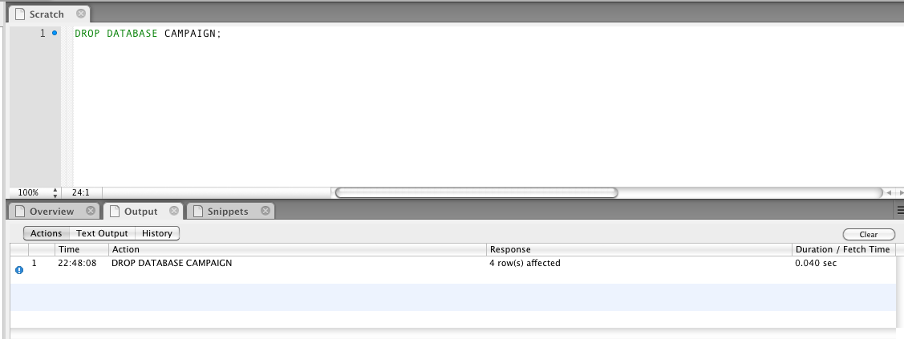

Turn in: (in this order)
- This exam electronically to Blackboard..
- Enjoy the break! See you Spring quarter.

